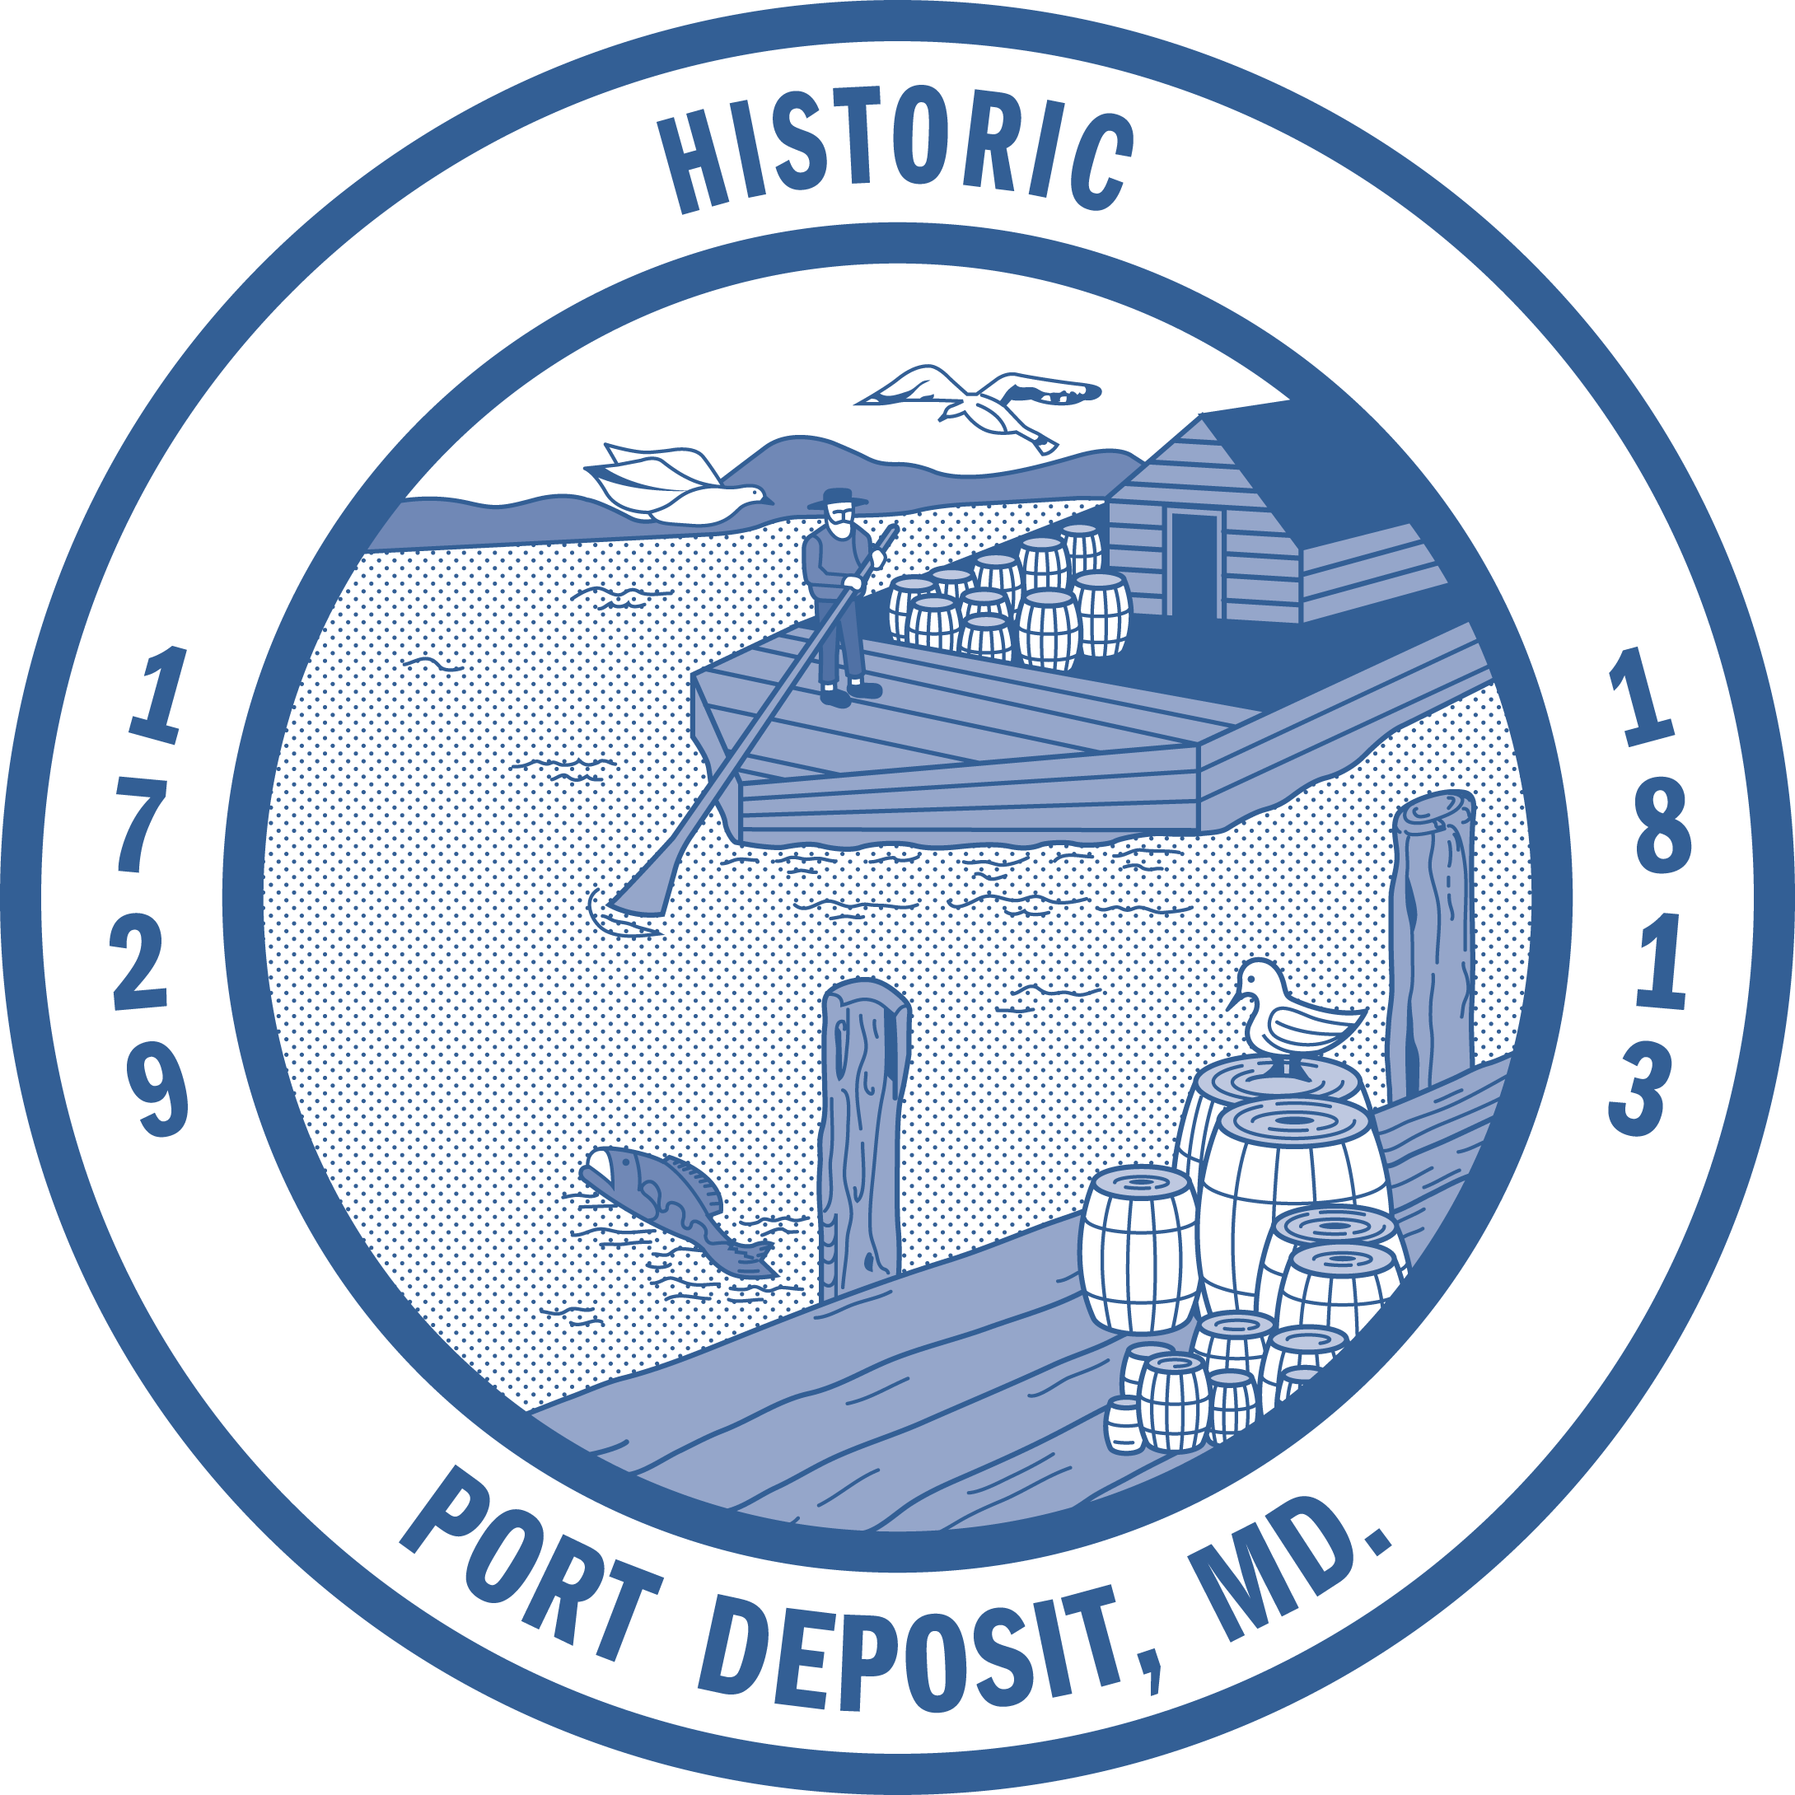
TOWN OF PORT DEPOSIT
TOWN COUNCIL WORK SESSION MEETING
Town Hall, 64 S. Main Street, Port Deposit

August 15, 2017 – 7:00 p.m.
REVISED AGENDA

- ALL TO ORDER

- PLEDGE OF ALLEGIANCE

- WELCOME BY MAYOR TOME

- REPORT
Sheriff’s Office Update – Corporal Sewell
SHA Stormdrain Project Update – Bob Rager, SHA Community Liaison

- NEW BUSINESS
Resolution 31-2017 – FY2019 Parks and Playground Grant application approval – Town
Administrator Rinkerman
Condemned Property Update – Mayor Tome
Agreement Electric Service Visitor Center – Finance Manager Sookiasian
Equipment Update – lawn mower – Finance Manager Sookiasian

- DISCUSSION
Working Waterfronts Grant – Town Administrator Rinkerman
Visitor Center Update – Suggestions from Volunteers – Town Administrator Rinkerman

- COUNCIL REPORTS

- PUBLIC COMMENT

- EXECUTIVE SESSION – No session scheduled.

The next meeting of the Council of the Town of Port Deposit is scheduled for Tuesday,
September 5, 2017 at 7:00 p.m. in Town Hall, 64 S. Main Street, Port Deposit.

