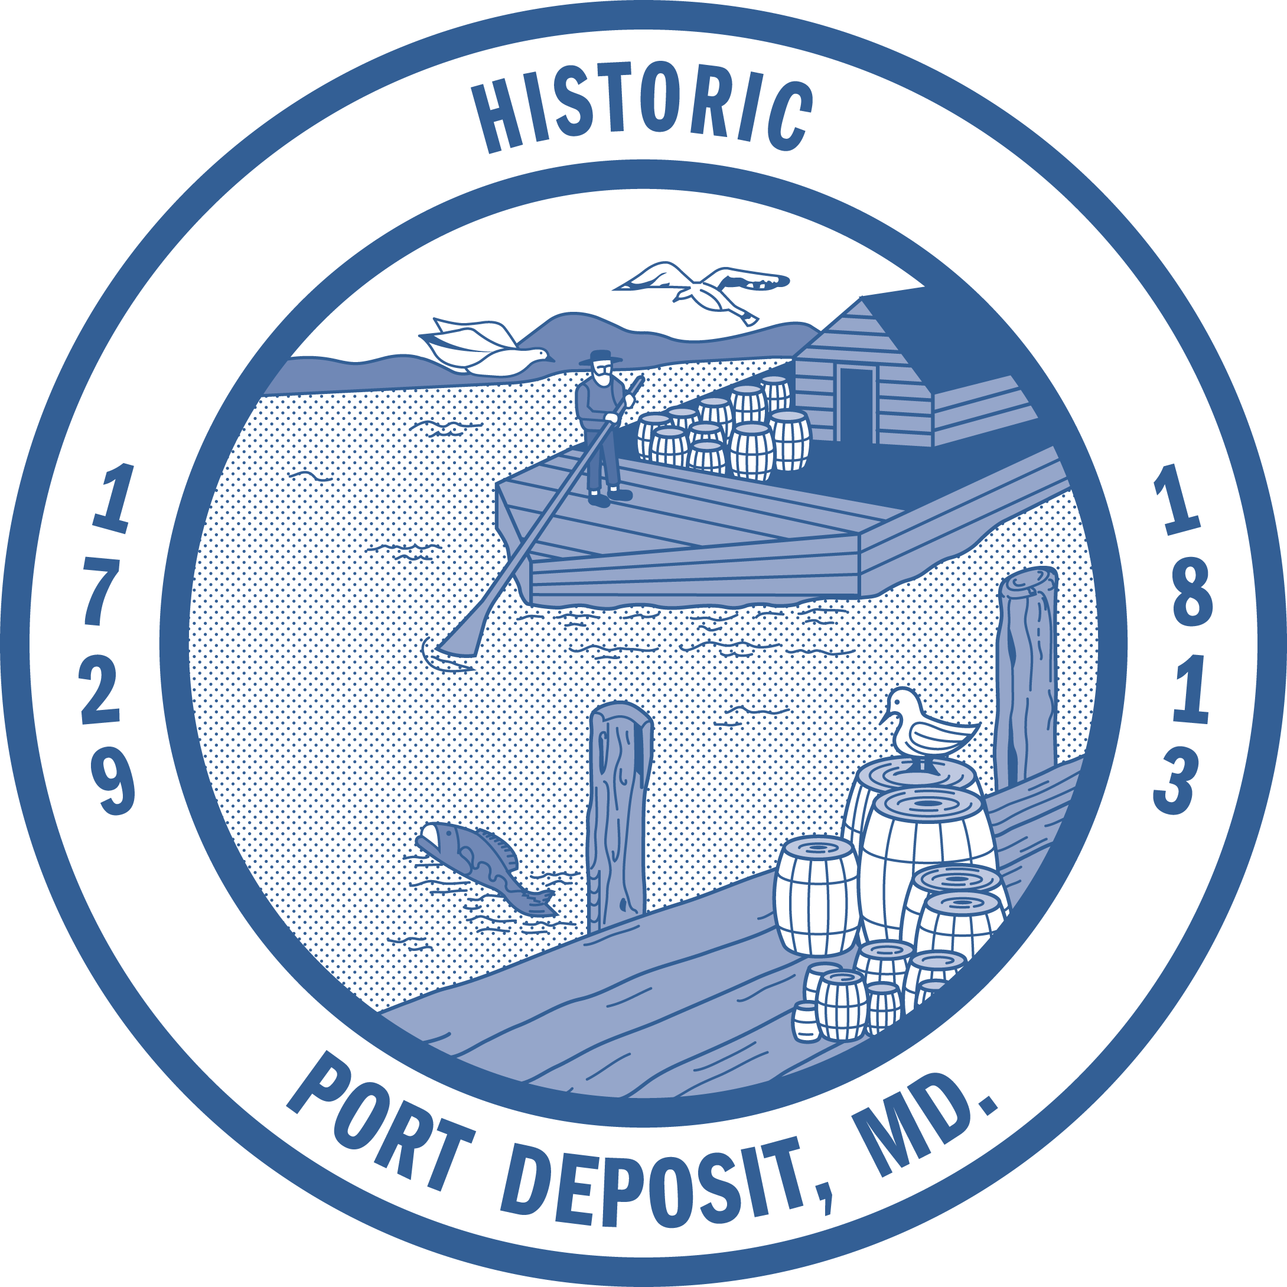
TOWN OF PORT DEPOSIT
TOWN COUNCIL WORK SESSION MEETING
Town Hall, 64 S. Main Street, Port Deposit

January 17, 2017 – 7:00 p.m.
REVISED AGENDA

- CALL TO ORDER – PLEDGE OF ALLEGIANCE

- WELCOME BY MAYOR TOME

- PRESENTATIONS
Tome Visitor Center Update – Linda Read, Project Manager
SHA Stormwater Project Update – Debra Keats and Ed Stein, SHA
SHA Rock Run Bridge Project Update – Debra Keats and Ed Stein, SHA
Sheriff’s Office Update – Corporal William Sewell

- PUBLIC COMMENT

- NEW BUSINESS

- OLD BUSINESS

- COUNCIL REPORTS

- PUBLIC COMMENT

- ANNOUNCEMENTS

- EXECUTIVE SESSION – Pursuant to the Annotated Code of Maryland, State Government, Title 10, Governmental Procedures, Subtitle 5, Section 10-508 (a) (3) to consider the acquisition of real property for a public purpose and matters directly related thereto; and (7) to consult with counsel to obtain advice on a legal matter relative to agreements. Council will not return to public session

The next meeting of the Council of the Town of Port Deposit is scheduled for Tuesday,
February 7, 2017 at 7:00 p.m. in Town Hall, 64 S. Main Street, Port Deposit.

